Equatorial Guinea

## Population Data

The data set shows the political stability estimate of the country each year.

## # A tibble: 23 x 5  
## country iso3c date population popCategory5  
## <chr> <chr> <dbl> <dbl> <chr>   
## 1 Equatorial Guinea GNQ 1996 515853 very small   
## 2 Equatorial Guinea GNQ 1997 536460 very small   
## 3 Equatorial Guinea GNQ 1998 558492 very small   
## 4 Equatorial Guinea GNQ 1999 581770 very small   
## 5 Equatorial Guinea GNQ 2000 606181 very small   
## 6 Equatorial Guinea GNQ 2001 631666 very small   
## 7 Equatorial Guinea GNQ 2002 658384 very small   
## 8 Equatorial Guinea GNQ 2003 686664 very small   
## 9 Equatorial Guinea GNQ 2004 716949 very small   
## 10 Equatorial Guinea GNQ 2005 749535 very small   
## 11 Equatorial Guinea GNQ 2006 784496 very small   
## 12 Equatorial Guinea GNQ 2007 821687 very small   
## 13 Equatorial Guinea GNQ 2008 860840 very small   
## 14 Equatorial Guinea GNQ 2009 901599 very small   
## 15 Equatorial Guinea GNQ 2010 943639 very small   
## 16 Equatorial Guinea GNQ 2011 986853 very small   
## 17 Equatorial Guinea GNQ 2012 1031191 very small   
## 18 Equatorial Guinea GNQ 2013 1076413 very small   
## 19 Equatorial Guinea GNQ 2014 1122276 very small   
## 20 Equatorial Guinea GNQ 2015 1168568 very small   
## 21 Equatorial Guinea GNQ 2016 1215179 very small   
## 22 Equatorial Guinea GNQ 2017 1262001 very small   
## 23 Equatorial Guinea GNQ 2018 1308974 very small

# Population growth data

## # A tibble: 23 x 5  
## country iso3c date popGrowth popGrowthCat5   
## <chr> <chr> <dbl> <dbl> <chr>   
## 1 Equatorial Guinea GNQ 1996 3.77 high growth rate  
## 2 Equatorial Guinea GNQ 1997 3.92 high growth rate  
## 3 Equatorial Guinea GNQ 1998 4.02 high growth rate  
## 4 Equatorial Guinea GNQ 1999 4.08 high growth rate  
## 5 Equatorial Guinea GNQ 2000 4.11 high growth rate  
## 6 Equatorial Guinea GNQ 2001 4.12 high growth rate  
## 7 Equatorial Guinea GNQ 2002 4.14 high growth rate  
## 8 Equatorial Guinea GNQ 2003 4.21 high growth rate  
## 9 Equatorial Guinea GNQ 2004 4.32 high growth rate  
## 10 Equatorial Guinea GNQ 2005 4.44 high growth rate  
## 11 Equatorial Guinea GNQ 2006 4.56 high growth rate  
## 12 Equatorial Guinea GNQ 2007 4.63 high growth rate  
## 13 Equatorial Guinea GNQ 2008 4.65 high growth rate  
## 14 Equatorial Guinea GNQ 2009 4.63 high growth rate  
## 15 Equatorial Guinea GNQ 2010 4.56 high growth rate  
## 16 Equatorial Guinea GNQ 2011 4.48 high growth rate  
## 17 Equatorial Guinea GNQ 2012 4.39 high growth rate  
## 18 Equatorial Guinea GNQ 2013 4.29 high growth rate  
## 19 Equatorial Guinea GNQ 2014 4.17 high growth rate  
## 20 Equatorial Guinea GNQ 2015 4.04 high growth rate  
## 21 Equatorial Guinea GNQ 2016 3.91 high growth rate  
## 22 Equatorial Guinea GNQ 2017 3.78 high growth rate  
## 23 Equatorial Guinea GNQ 2018 3.65 high growth rate

## Population trend

The plot shows the population trend of the country.

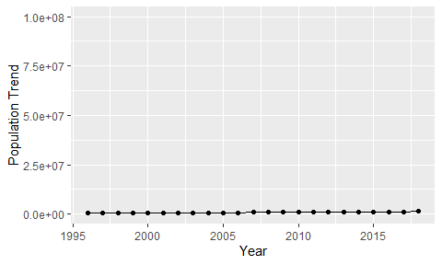

Political Stability Trend

# Population growth trend

The plot shows the population growth rate trend of the country.

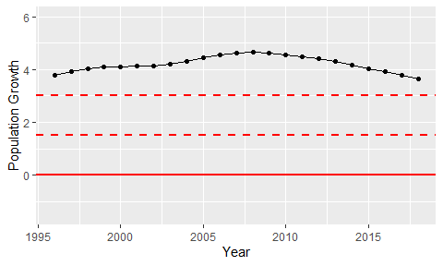

Population Growth Trend